E-learning platforms

Definition:
# Source: AI Source: Provided by: [Data Path: Persons Table -> ID Column: 1, Name_En Column: Motasem Essam] -> From: [Chatgpt (GPT‑5 Mini)] on [2/12/2026]
E-learning platforms are websites or web apps designed to deliver education, courses, and training online. They allow learners to study anytime, anywhere, often with interactive tools.

Simple Definition
# Source: AI Source: Provided by: [Data Path: Persons Table -> ID Column: 1, Name_En Column: Motasem Essam] -> From: [Chatgpt (GPT‑5 Mini)] on [2/12/2026]
E-learning platform = an online school or course system where people learn skills or subjects digitally.

What E-learning Platforms Usually Include
# Source: AI Source: Provided by: [Data Path: Persons Table -> ID Column: 1, Name_En Column: Motasem Essam] -> From: [Chatgpt (GPT‑5 Mini)] on [2/12/2026]
- Courses / Lessons – structured learning material
- Videos & Tutorials – visual and interactive learning
- Quizzes & Tests – assess understanding
- Progress Tracking – monitor completion and scores
- Certificates / Badges – recognition for completing courses
- Discussion Forums / Chats – interact with teachers and other learners
- Payment System (optional) – for paid courses

Examples of E-learning Platforms
# Source: AI Source: Provided by: [Data Path: Persons Table -> ID Column: 1, Name_En Column: Motasem Essam] -> From: [Chatgpt (GPT‑5 Mini)] on [2/12/2026]
- Coursera – online courses and degrees
- Udemy – skill-based paid courses
- Khan Academy – free educational content for students
- Duolingo – language learning
- Codeacademy – coding courses

Purpose of E-learning Platforms
# Source: AI Source: Provided by: [Data Path: Persons Table -> ID Column: 1, Name_En Column: Motasem Essam] -> From: [Chatgpt (GPT‑5 Mini)] on [2/12/2026]
- Provide flexible learning online
- Reach learners globally
- Track progress and performance
- Offer certifications for skills
- Combine learning materials, assessments, and interaction in one place

Difference from School/College Websites
# Source: AI Source: Provided by: [Data Path: Persons Table -> ID Column: 1, Name_En Column: Motasem Essam] -> From: [Chatgpt (GPT‑5 Mini)] on [2/12/2026]
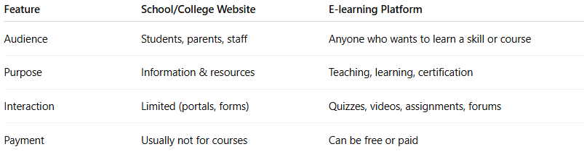
Feature | School/College Website | E-learning Platform
Audience | Students, parents, staff | Anyone who wants to learn a skill or course
Purpose | Information & resources | Teaching, learning, certification
Interaction | Limited (portals, forms) | Quizzes, videos, assignments, forums
Payment | Usually not for courses | Can be free or paid

